PROJECT EXPO
TEAM MEMBERS:
RAMACHANDRAN R S
ALFRED ALENSO J
PRIYADHARSHINI V
MADHUMITHA J
SMART VEHICLE ACCIDENT DETECTION AND EMERGENCY RESCUE SYSTEM

1.Brainstorming report
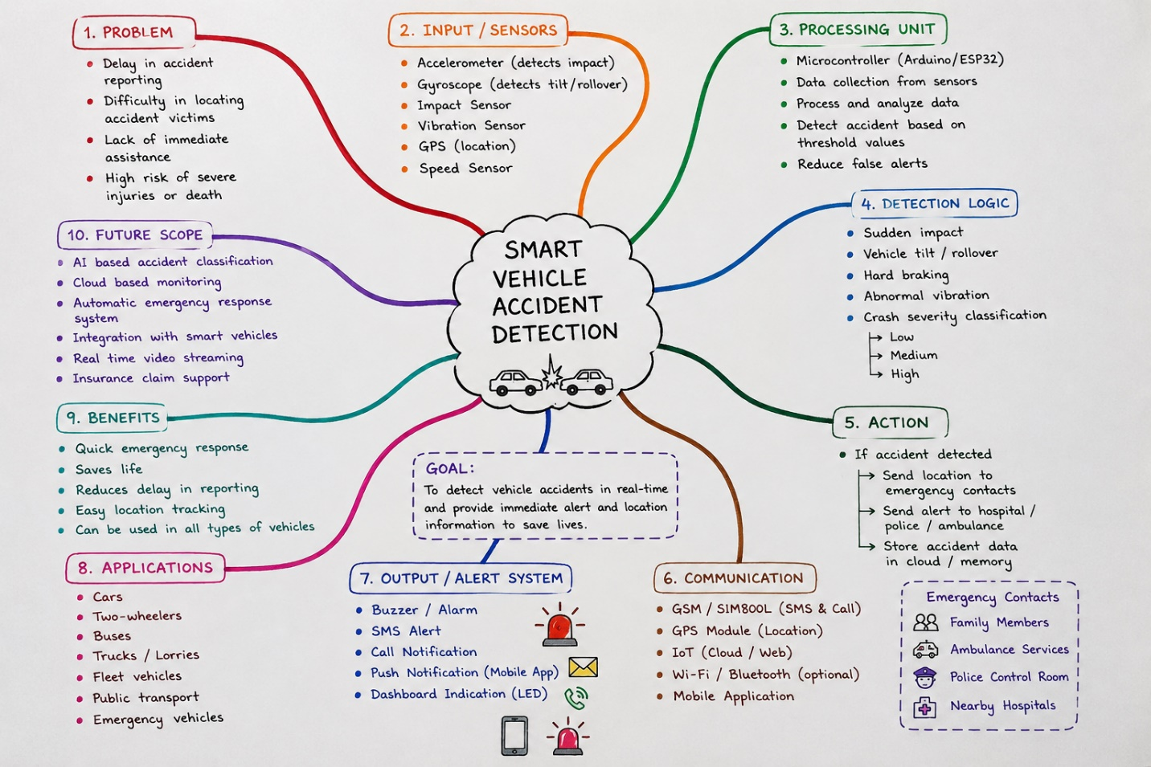

2.Idea prioritization matrix
idea | Feature | Impact | Effort | Priority
Accident Detection
  Accelerometer + Gyroscope
  High
  Medium
  High
Location Tracking
  GPS-based real-time location
  High
  Low
  High
Emergency Alert | GSM SMS/Call |  | medium | high
  Very High
Driver Verification | Fingerprint/RFID/Face verification | high | high | medium
IoT Monitoring | Cloud-based vehicle monitoring | high | medium | high
Local Alert | Buzzer + LED warning | medium | low | medium
Mobile Notification | App-based emergency notification |  | high | medium
  High
Accident Data | Event logging and history | medium | low | medium
Intelligent Detection | AI/ML accident classification | Very high | Very high | medium
Emergency Rescue | Share location with family/emergency contacts | Very high | medium | high
Vehicle Security |  | high | medium | high
  Unauthorized-driver warning
Future Feature | Automatic emergency-service integration | Very high | Very high | low

3.Empathy map
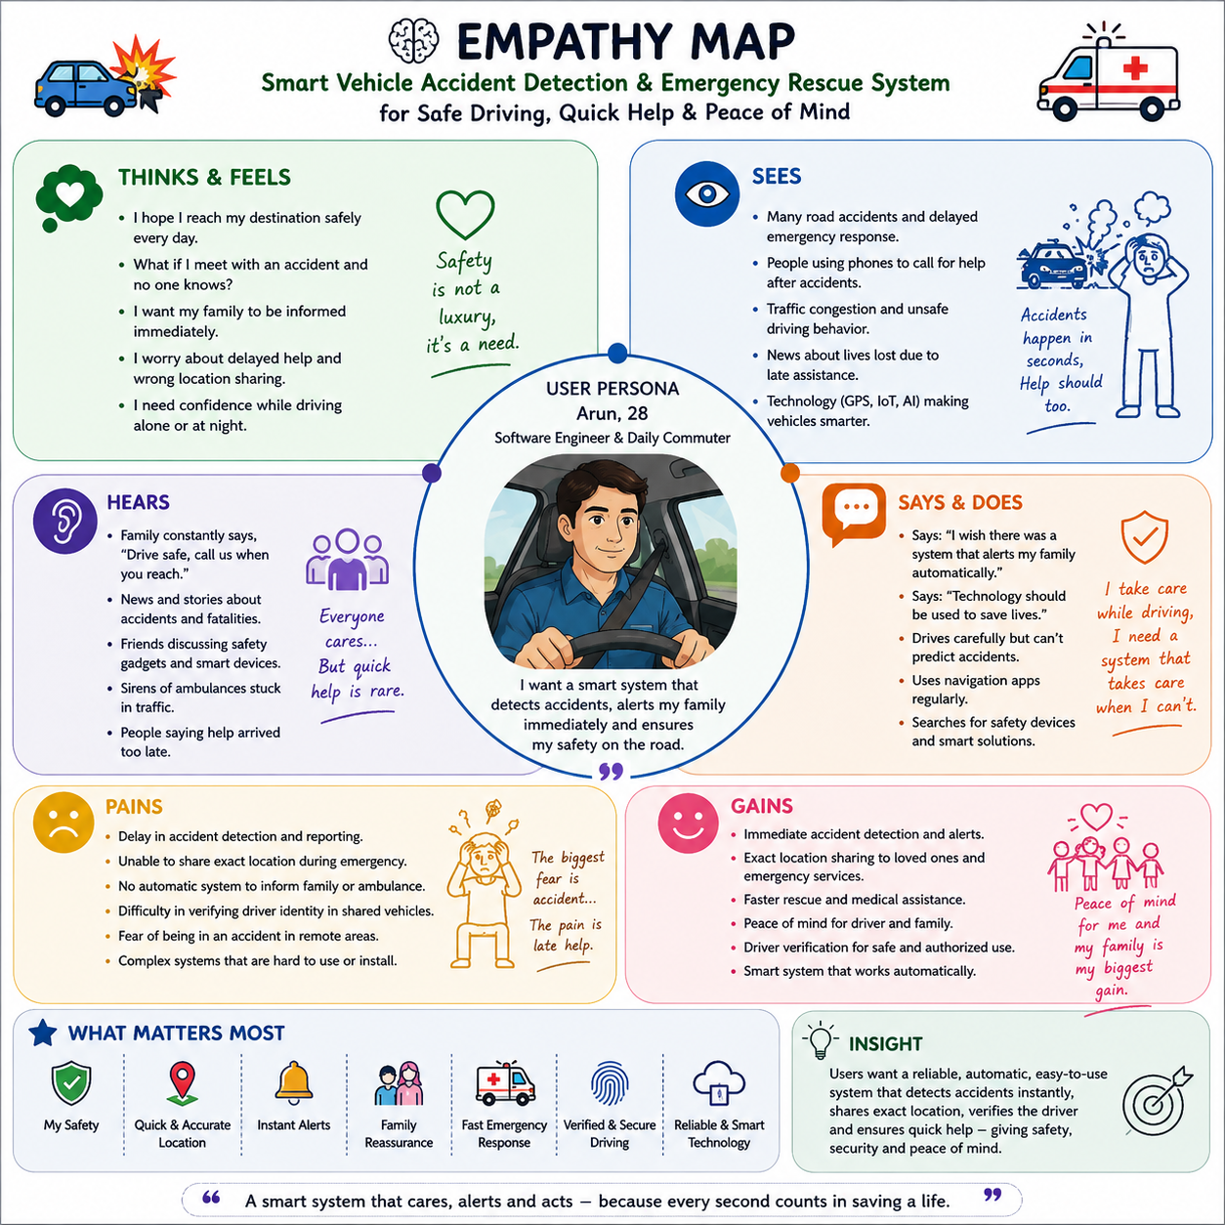

4.User Persona
Persona Name: Arjun Kumar
Age: 21 years
Occupation: College Student
Location: Chennai, Tamil Nadu
Vehicle: Two-wheeler
Technology Level: Moderate
Daily Travel: College, home, tuition, and part-time activities

5.Proposed solution
- Intelligent Driver Verification – The system verifies the authorized driver before allowing vehicle operation.
- Accident Detection – An accelerometer/gyroscope and impact sensor continuously monitor sudden acceleration, tilt, vibration, and impact.
- Accident Confirmation – When abnormal sensor values are detected, the ESP32 analyzes the readings to distinguish a possible accident from normal conditions such as braking or road bumps.
- GPS Location Tracking – The GPS module obtains the vehicle's real-time latitude and longitude.
- Emergency Alert – The GSM module automatically sends an SMS containing the accident alert and location to predefined emergency contacts.
- IoT Monitoring – Accident and vehicle information can be uploaded to an IoT platform for remote monitoring.
- Emergency Rescue – The location information helps family members or emergency responders identify the accident location and respond faster.
- Driver Safety Monitoring – The system can also monitor selected driver-related parameters and generate an alert when unsafe conditions are detected.

6.Functional requirements
S.No | Functional Requirements | Description
1 | Driver verification | The system shall verify the identity of the authorized driver before vehicle operation.
2 | Sensor monitoring | the system shall continuously monitor acceleration, vibration, tilt, and impact using suitable sensors.
3 | Accident detection | The system shall detect a possible accident when sensor readings exceed predefined threshold values.
4 | GPS tracking | The system shall obtain the vehicle's current latitude and longitude using a GPS module.
5 | Emergency alert | The system shall automatically generate an emergency alert when an accident is confirmed.
6 | GSM communication | The GSM module shall send an SMS containing the accident information and GPS location to predefined emergency contacts.
7 | IOT Data transmission | The ESP32 shall transmit relevant vehicle and accident information to an IoT/cloud platform when network connectivity is available.
8 | Real-time monitoring | The system shall allow authorized users to monitor vehicle status and accident information remotely through the IoT platform.
9 | Location sharing | The system shall provide the accident location in a format that can be used to identify the vehicle's location on a map.
10 | Emergency contact notification | The system shall notify predefined contacts immediately after a confirmed accident.
11 | System status monitoring | the system shall monitor the operational status of sensors, GPS, GSM, and ESP32 components.
12 | Alert indication | The system shall provide a visual or audible indication when an accident or abnormal condition is detected.
13 | Data logging | The system shall record important accident details such as time, sensor readings, and location for later analysis.
14 | Accident confirmation | The ESP32 shall analyze multiple sensor readings to reduce false accident detection caused by potholes, speed breakers, or sudden braking.

7.Non-Functional requirements
1. Reliability – The system should reliably detect accidents and send emergency alerts with minimum failure.
2. Accuracy – The system should accurately identify accident conditions and provide the correct GPS location.
3. Fast Response – The system should detect an accident and send the emergency alert with minimum delay.
4. Low Power Consumption – The system should consume less power so that it does not significantly drain the vehicle battery.
5.Security – Driver and vehicle information should be protected from unauthorized access.
6. Availability – The system should remain active and ready to detect accidents whenever the vehicle is operating.
7.Durability – The hardware should withstand vehicle vibration, movement, dust, and normal temperature variations.
8. Usability – The system should be simple to operate and should require minimal driver interaction.
9.Maintainability – The system should be easy to test, troubleshoot, repair, and upgrade.
10. Scalability – The system should allow additional sensors and safety features to be added in the future

8.Project planning

S.No | Project phase | Major activities | Expected outcomes
1 | Problem Identification | identify accident-related problems and emergency response delays. | Problem statement
2 | Requirement analysis | Identify hardware, software, functional, and non-functional requirements. | Requirement specification
3 | System design | Prepare block diagram, circuit design, and system architecture. | System design
4 | Hardware development | Integrate ESP32, sensors, GPS, GSM, and driver verification module. | Hardware prototype
5 | Software development | Develop programs for sensor monitoring, accident detection, and communication. | Working prototype
6 | Iot integration | Connect the system to an IoT platform for remote monitoring and data logging. | Iot monitoring
7 | System integration | Combine hardware and software and verify module communication. | Complete system
8 | Testing | test accident detection, GPS, GSM alerts, driver verification, and false alarms. | Tested prototype
9 | Evaluation and improvement | Analyze accuracy, response time, reliability, and power consumption. | Improved system
10 | Documentation & demonstration | Prepare report, results, presentation, and final demonstration. | Final project

Risk Analysis
- False Accident Detection: Potholes, speed breakers, or sudden braking may trigger false alerts.
Mitigation: Use multiple sensors and appropriate threshold values.
- GPS Signal Failure: The system may fail to obtain the exact accident location.
Mitigation: Use repeated GPS readings and store the last valid location.
- GSM Network Failure: Emergency SMS may not be delivered immediately.
Mitigation: Retry message transmission when network connectivity is restored.
- Sensor Failure: A damaged or faulty sensor may affect accident detection.
Mitigation: Monitor sensor status and use multiple sensing parameters.
- Power Failure: The system may stop functioning if the power supply fails.
Mitigation: Use a stable power supply and suitable backup power.
- IoT Connectivity Failure: Accident data may not reach the cloud platform.
Mitigation: Store data locally and upload it when connectivity is available.
- Hardware Damage: Vehicle vibration, dust, or temperature may damage components.
Mitigation: Use a protective enclosure and secure component mounting.
- Software Errors: Programming errors may cause incorrect detection or alerts.
Mitigation: Perform unit testing and complete system testing.
- Driver Verification Failure: The system may incorrectly accept or reject a driver.
Mitigation: Test the verification system with different authorized and unauthorized inputs.
- communication Delay: Emergency information may reach contacts late.
Mitigation: Optimize the communication process and implement automatic retry mechanisms.

